Kitchen Story

# Project Details

This project aims to design and develop an E-commerce website that lets people shop basic food items using Angular and Spring boot. It enables users to search and buy the available products. It was developed as a project of Phase-4 for the Full Stack Java

Developer course.

# Product Backlog:

1. Create database and tables.
2. Initialize a Spring Boot project for the Back-End side.
3. Create REST APIs with spring Data JPA Repositories
4. Create a new Angular project for the Front-End side.
5. Create login and register pages.
6. Show all products to the home page.
7. Create a product details component.
8. Search a product by a category.
9. Search a product by a keyword.
10. Add products to the cart.
11. Show user’s cart.
12. Remove a product from the cart.
13. Update user account
14. Create the admin view
15. Delete a product for the admin
16. Add a new product for the admin
17. Add bootstrap and font awesome to the components.
18. Debug and test the project.

# Technologies and tools Used

1. Angular: used in the front-end side to build modern single-page applications
2. Spring Boot: used in the back-end side to create the REST API and retrieve data from a database.
3. HTML/CSS: to create and format the content of the pages.
4. Bootstrap: to use some CSS and JavaScript designs.
5. Maven: to manage the project.
6. Visual Studio Code: to write and run the Angular code.
7. Eclipse: to write and run the Spring Boot code.
8. MyAdmin: to administrate and manage the database manually.

# Flowcharts of The Application

Flow chart is for submit number 1 (some few changes were not added here)

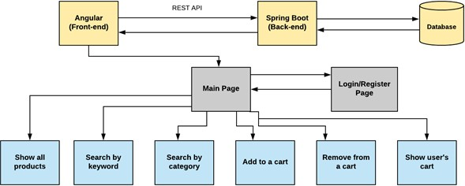

# Core concepts used in the project.

1. Object-Oriented: used to create and model objects for users and their credentials.
2. REST API: used to communicate between the back-end and the front-end sides.
3. Data Access Object: to abstract and encapsulate all access to the data source.
4. Object–Relational Mapping: to map the objects to the database.
5. Databases: used to store and retrieve data.
6. Data Sources: used to define a set of properties required to identify and access the database.
7. Collections: used some collections such Array list to store collection of data.
8. Exception Handling: used to catch problems that arises in the code especially in I/O blocks.

Screenshots

